SIMATS ENGINEERING
SAVEETHA INSTITUTE OF MEDICAL AND TECHNICAL SCIENCES
COMPUTER SCIENCE AND ENGINEERING PROGRAMME
CSA1302 - THEORY OF COMPUTATION
LAB Experiment - 2
Name: Sanjana. G
Reg No: 192511020

QUESTION
1. Write a C program to simulate a Non-Deterministic Finite Automata (NFA) for the given language representing strings that start with 0 and end with 1.

1. AIM
To write and execute a C program to simulate an NFA that accepts binary strings which start with '0' and end with '1'.

2. ALGORITHM
- Start the program.
- Read a binary string containing only 0 and 1.
- Check that every character is either 0 or 1.
- Check whether the string has at least two characters, starts with 0, and ends with 1.
- If all conditions are satisfied, print “String Accepted”; otherwise, print “String Rejected”.
- Stop the program.

3. PROGRAM
#include <stdio.h>
#include <string.h>
int main() {
char str[100];
int i, n;
printf("Enter a binary string (0 and 1): ");
scanf("%99s", str);
n = strlen(str);
for (i = 0; i < n; i++) {
if (str[i] != '0' && str[i] != '1') {
printf("Invalid input\\n");
return 0;
}
}
if (n >= 2 && str[0] == '0' && str[n - 1] == '1')
printf("String Accepted\\n");
else
printf("String Rejected\\n");
return 0;
}

4. OUTPUT
The program was executed with the input string "001".
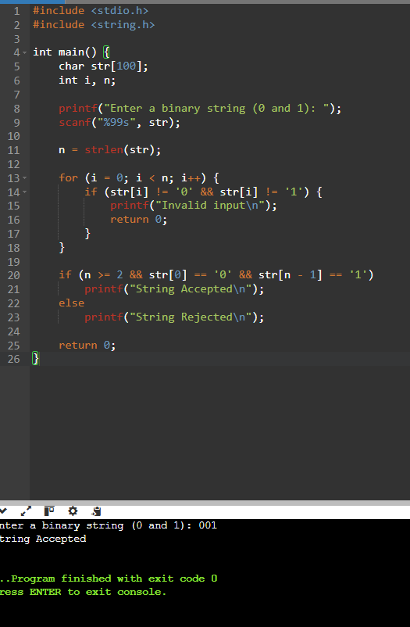
Output screenshot: Input = 001; String Accepted.

5. RESULT
Thus, the C program to simulate an NFA for binary strings that start with '0' and end with '1' was written and executed successfully. The input string "001" was accepted.

